Manual Instruction
Mini Angle Polisher

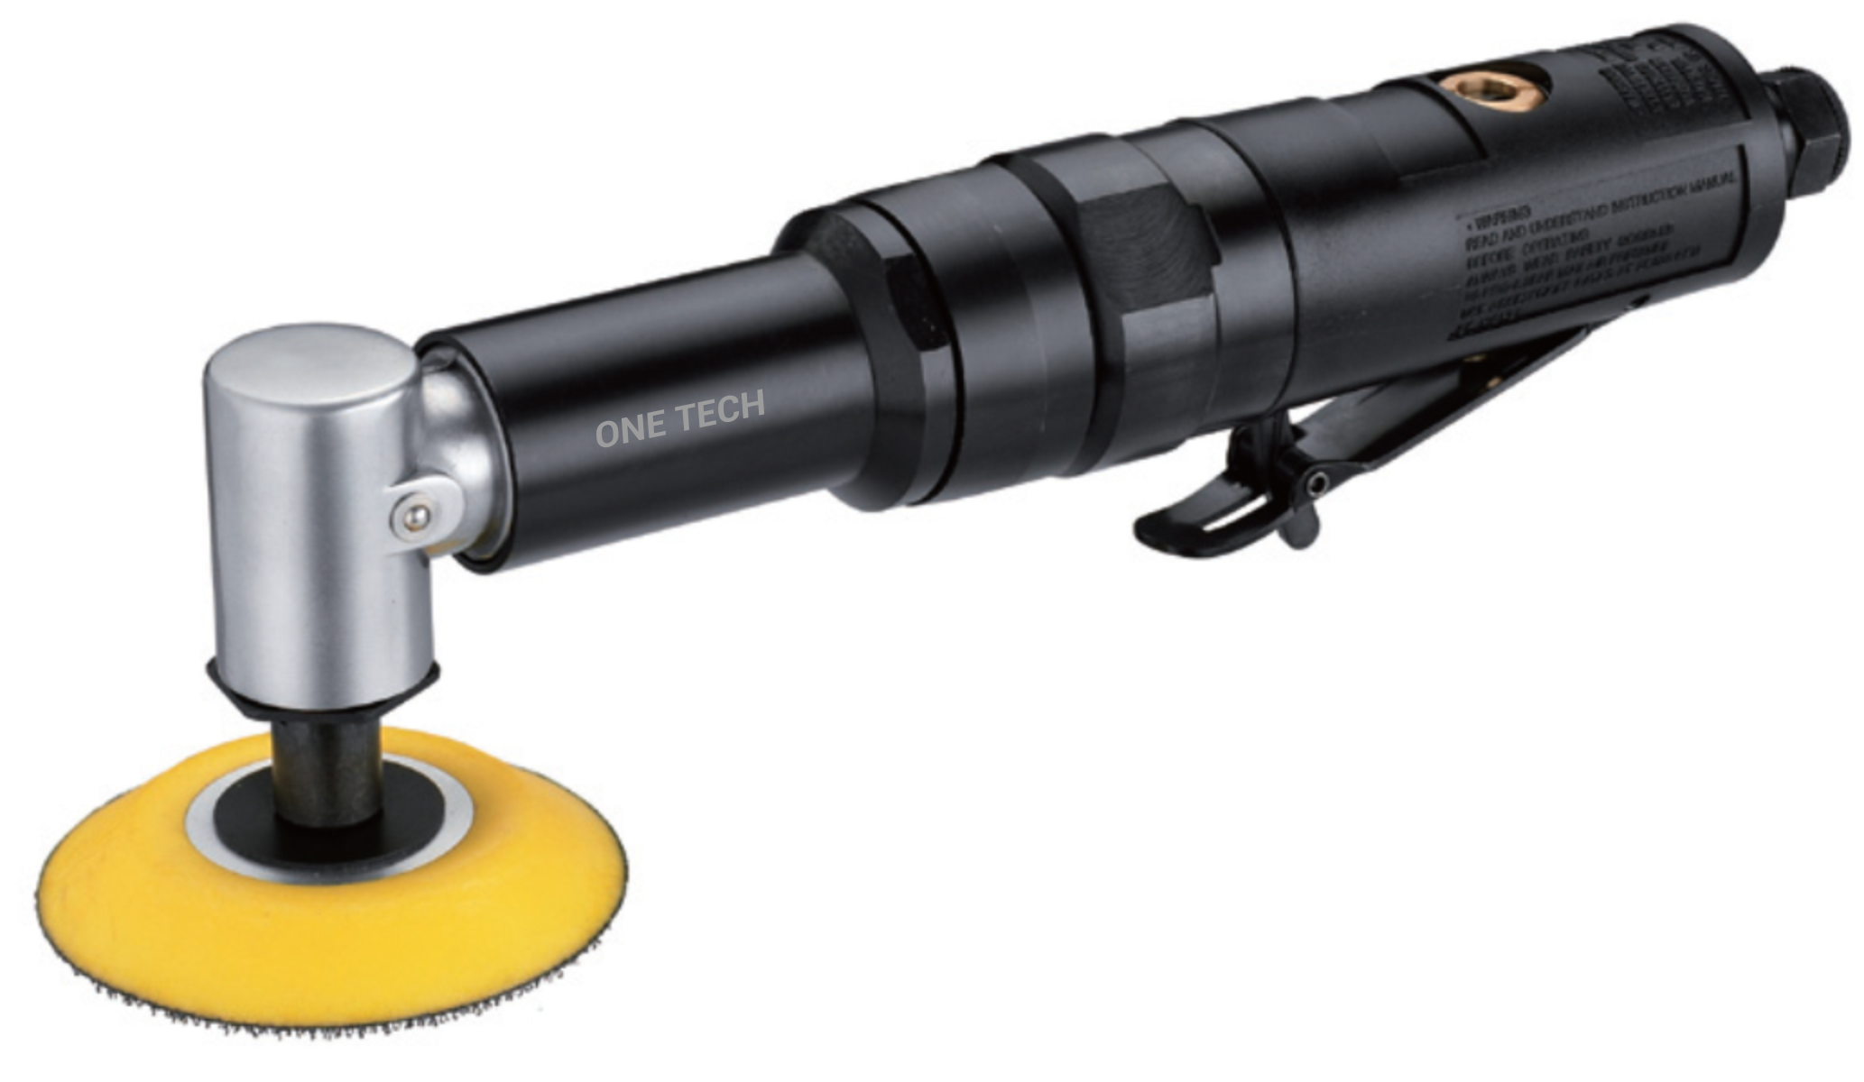

 | model: | NT09-403

ATTENTION! PLEASE READ THIS MANUAL BEFORE USING THE TOOL.
IMPROPER USE OF TOOL MAY CAUSE INJURY AND/OR PROPERTY DAMAGE!
ONLY QUALIFIED AND SPECIALLY TRAINED PERSONNEL FAMILIED WITH THESE INSTRUCTIONS IS ALLOWED TO USE AND MAINTENANCE OF THE TOOL.
This manual contains description, safety rules and all the information necessary for the correct use of the pneumatic tool.
The safety advice given in this manual is in addition to and does not replace the general safety regulations applicable in the region where the Tool is used.
- Potential injury from moving parts.
- There may be an increased level of noise, vibration.
- Excessive dustiness of the air in the working area may occur.
GENERAL RULES OF OPERATION
- When working with the tool always use personal protective equipment appropriate for the type of work performed (goggles, impact resistant glasses, hand protection, body, etc.);
- The employee's appearance must comply with safety requirements. Loose clothing, jewelry or long hair can be caught in the rotating parts of the tool;
- The rated speed of the accessories used must exceed the maximum indicated tool speed;
- To ensure maximum performance and durability of the tool, the working pressure of the compressed air should be set at 6.2 bar;
- Do not operate the tool in an explosive environment containing flammable liquids, gases, or dust. During operation, sparks may form, from which ignition is possible;
- High noise levels can cause hearing loss. Timely maintenance will help avoid an increase in noise levels;
- The tool may generate vibration during use. Prolonged vibration can damage hands and / or other parts of the body. In case of any unpleasant sensations in the hands and wrists, you must stop working;
- The flow of compressed air can cause serious injury. Never direct the air flow towards yourself or others. Do not use compressed air to clean clothes;
- Before starting work, check the compressed air supply hoses for damage, wear or other defects. Replace immediately if found;
- Do not carry the tool by the compressed air supply hoses;
• Check screw connections before starting work. Tighten if necessary;
- Possible sudden changes in movement during start-up and operation;
- Do not try to lock the ON / OFF lever in the ON position. The lever should independently and freely return to the "OFF" position after being released;
- The workpiece to be processed must be securely fixed;
- Always disconnect the tool from the compressed air line before changing abrasives, accessories, performing maintenance or adjusting parameters;
- Before installing on the tool, inspect the abrasives (accessories) for damage or defects.

MAINTENANCE
- Before and after operating, place a few drops of SAE #10 into inlet bushing with throttle lever pressed down to allow lubricating oils to properly dispense through machine.
- Connect the compressed air pipe and run for a few seconds, the tool for oil distribution on the tool.
NOTE: it is possible the yield of oil through the exhaust hole. To prevent the ingress of oil on the workpiece and / or of the operator to close the exhaust hole with a rag.
STORAGE
- Avoid storing the instrument in conditions of high humidity.
- Lubricate the tool before long-term storage (see MAINTENANCE).
ITEM DESIGN HANGE
- It is forbidden to make changes to the design of the tool without the consent of the manufacturer.
DISPOSAL
- When disposing of the tool or individual components, observe the local regulations in force in the region where the equipment is used.
THE AIR SUPPLY SYSTEM
- For maximum performance and durability of parts, the operating inlet pressure should be set at 6.2 bar.
- Recommended diameter of the compressed air hose 3/8" (≈ 9 mm).
- Always use clean, dry air.
- Drain the water from the air line before starting work. Install a filter drier in the air line.
- Maintain the necessary supply of compressed air in the air line for trouble-free and optimal tool performance.
EXAMPLE OF AIR SUPPLY SYSTEM
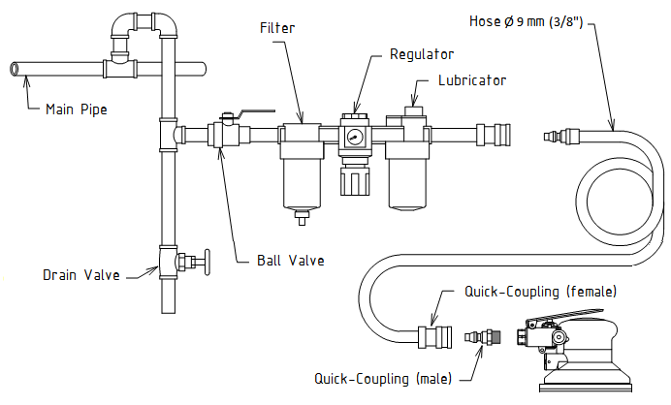

Troubleshooting guide
Not operating
Possible Cause | Solution
Blades broken or worn out | Replace blades
Ball bearing damaged | Replace ball bearing
Rusty Motor or clogged with objects | Disassemble and repair
Motor blades stuck | Disassemble and repair
Regulator is set at «OFF» | Adjust regulator
No air flow | Check air system and connections
Valve set damaged or broken | Disassemble and repair
Low efficiency
Possible Cause |  |  | Solution
Not enough air pressure |  |  | Check air pressure
Regulator is not set properly |  |  | Adjust regulator
Motor running abnormal or unusual noises occur
Possible Cause |  | Solution
Not enough lubrication |  | Lubricate
Ball bearing, cylinder, rotor blade, shaft damaged |  | Replace parts
Motor keeps running
Possible Cause |  | Solution
Valve set has other objects stuck on it |  | Remove foreign objects
Throttle valve or spring broken |  | Disassemble and repair
Valve seat broken, damaged |  | Disassemble and repair
Throttle valve broken |  | Replace parts

TECHNICAL SPECIFICATION
Model | Pad size,  mm | Speed,  rpm | Air consumption,  lpm | Length,  mm | Height,  mm | Pad Face | Spindle | Weight,  kg
NT09-403 | 75 | 2 300 | 50 | 245 | 54 | Hook | M10 | 1,1

Working pressure, bar | Air inlet thread
6.2 | 1/4"

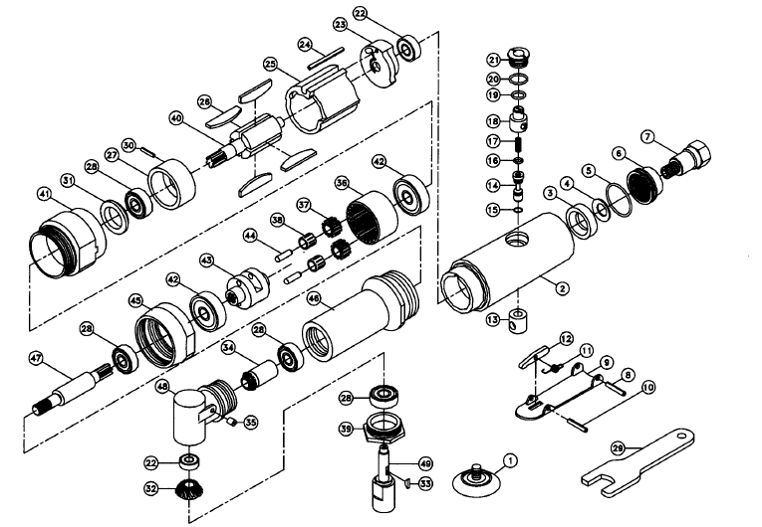

No. | Description | Part No. | Q'ty |  | No. | Description | Part No. | Q'ty
1 | 77 mm Sanding Pad | NT09S-0455 | 1 |  | 26 | Rotor Blade | NT09S-0480 | 4
2 | Motor Housing | NT09S-0456 | 1 |  | 27 | Front End Plate | NT09S-0481 | 1
3 | Silencer | NT09S-0457 | 1 |  | 28 | Ball Bearing | NT09S-0482 | 4
4 | Washer | NT09S-0458 | 1 |  | 29 | Spanner Wrench 11mm | NT09S-0483 | 1
5 | O-Ring | NT09S-0459 | 1 |  | 30 | Pin | NT09S-0484 | 1
6 | Deflector | NT09S-0460 | 1 |  | 31 | Rubber Gasket | NT09S-0485 | 1
7 | Air inlet | NT09S-0461 | 1 |  | 32 | Bevel Gear | NT09S-0486 | 1
8 | Lever Pin | NT09S-0462 | 1 |  | 33 | Key | NT09S-0487 | 1
9 | Throttle Lever | NT09S-0463 | 1 |  | 34 | Pinion | NT09S-0488 | 1
10 | Spring Pin | NT09S-0464 | 1 |  | 35 | Grease Fitting | NT09S-0489 | 1
11 | Spring | NT09S-0465 | 1 |  | 36 | Annular Gear | NT09S-0490 | 1
12 | Stop Rod | NT09S-0466 | 1 |  | 37 | Pinion Gear | NT09S-0491 | 2
13 | Valve Bushing | NT09S-0467 | 1 |  | 38 | Needle Bearing | NT09S-0492 | 2
14 | Valve Stem | NT09S-0468 | 1 |  | 39 | Clamp Nut | NT09S-0493 | 1
15 | O-Ring | NT09S-0469 | 1 |  | 40 | Rotor | NT09S-0494 | 1
16 | O-Ring | NT09S-0470 | 1 |  | 41 | Housing Lock Ring | NT09S-0495 | 1
17 | Spring | NT09S-0471 | 1 |  | 42 | Ball Bearing | NT09S-0496 | 2
18 | Regulator | NT09S-0472 | 1 |  | 43 | Gear Complete | NT09S-0497 | 1
19 | O-Ring | NT09S-0473 | 1 |  | 44 | Pin | NT09S-0498 | 2
20 | O-Ring | NT09S-0474 | 1 |  | 45 | Coupling | NT09S-0499 | 1
21 | Valve Screw | NT09S-0475 | 1 |  | 46 | Socket | NT09S-0500 | 1
22 | Ball Bearing | NT09S-0476 | 2 |  | 47 | Transmission shaft | NT09S-0501 | 1
23 | Rear End Plate | NT09S-0477 | 1 |  | 48 | Anglehead Housing | NT09S-0502 | 1
24 | Cylinder Pin | NT09S-0478 | 1 |  | 49 | Spindle | NT09S-0503 | 1
25 | Cylinder | NT09S-0479 | 1

info@onetech-tools.com
www.onetech-tools.com

